AI ASSISTED CODING – LAB ASSIGNMENT 4.2
Advanced Prompt Engineering – Zero-shot, One-shot, and Few-shot Techniques
Name: Adarsh Challa
H.TNO:2303A51044
Course Title: AI Assisted Coding
Assignment No: 4.2
Year / Semester: III / II
Regulation: R23

Task 1: Zero-Shot Prompting – Prime Number Check
Prompt (Zero-Shot)
Write a Python function to determine whether a given number is prime.
AI Generated Code
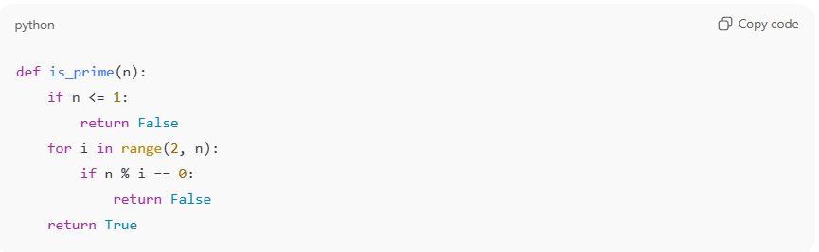Sample Output
Input: 7 → Output: Prime
Input: 10 → Output: Not Prime
Observation
Since no examples were given, the AI generated a basic solution.
The logic is correct but not optimized.
Conclusion
Zero-shot prompting gives working code, but it may not be efficient or well-optimized.

Task 2: One-Shot Prompting – Sum of Elements in a List
Prompt (One-Shot)
Example:
Input: [1, 2, 3, 4]
Output: 10
Write a Python function to calculate the sum of elements in a list.
AI Generated Code
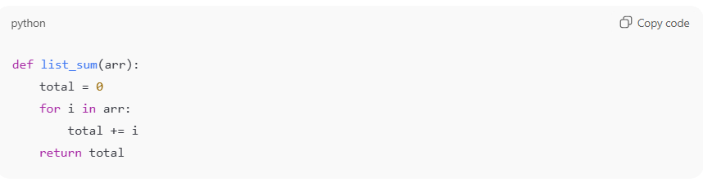Sample Output
Input: [5, 10, 15]
Output: 30
Observation
The single example helped the AI clearly understand the requirement.
The code is simple and correct.
Conclusion
One-shot prompting improves clarity and reduces confusion compared to zero-shot prompting.

Task 3: Few-Shot Prompting – Extract Digits from Alphanumeric String
Prompt (Few-Shot Examples)
Input: "a1b2c3" → Output: "123"
Input: "x9y8" → Output: "98"
Input: "abc" → Output: ""
Write a Python function to extract digits from an alphanumeric string.
AI Generated Code
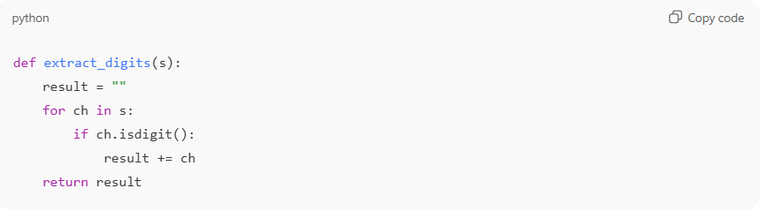Sample Output
Input: "p4q5r6"
Output: "456"
Observation
Because multiple examples were provided, the AI generated accurate and reliable code.
Conclusion
Few-shot prompting helps the AI understand patterns better and handle different cases correctly.

Task 4: Comparison – Zero-Shot vs Few-Shot (Vowel Count)
Zero-Shot Prompt
Write a Python function to count vowels in a string.
Zero-Shot Code
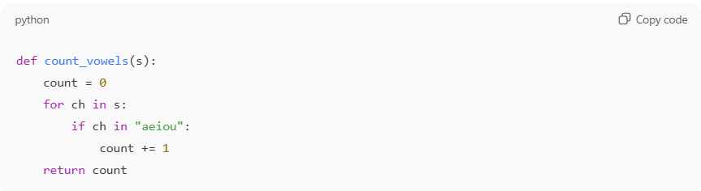
Few-Shot Prompt
Examples:
"hello" → 2
"aeiou" → 5
"xyz" → 0
Write a Python function to count vowels in a string.
Few-Shot Code
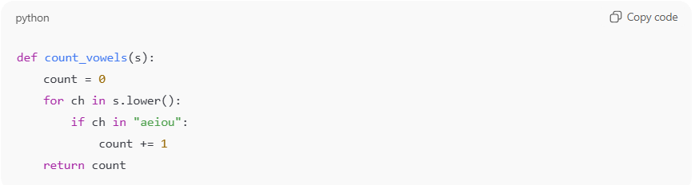
Comparison
Feature | Zero-Shot | Few-Shot
Handles uppercase | No | Yes
Accuracy | Medium | High
Code quality | Basic | Better
Observation
Few-shot prompting improved accuracy by handling uppercase letters and edge cases.
Conclusion
Examples help the AI generate more complete and correct code.

Task 5: Few-Shot Prompting – Minimum of Three Numbers
Prompt (Few-Shot Examples)
Input: (3, 7, 5) → Output: 3
Input: (10, 2, 8) → Output: 2
Input: (6, 6, 9) → Output: 6
Write a Python function to find the minimum of three numbers without using min().
AI Generated Code
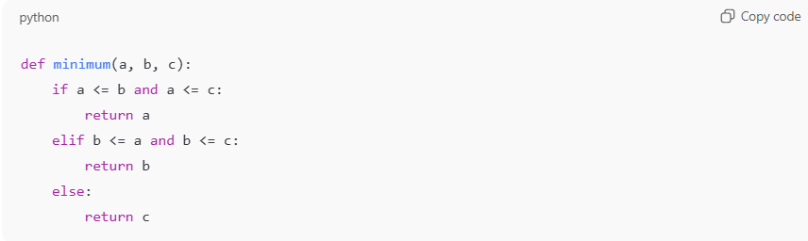Sample Output
Input: (4, 9, 1)
Output: 1
Observation
The examples helped the AI cover all comparison cases correctly.
Conclusion
Few-shot prompting is very effective when logic depends on conditions and comparisons.

